

SCHOLARSHIP PROGRAM

EXPRESSION OF INTEREST
Entry at Year 7 - 2027
Reservoir High is proud to reward talented Grade 6 students who also display leadership and respect.
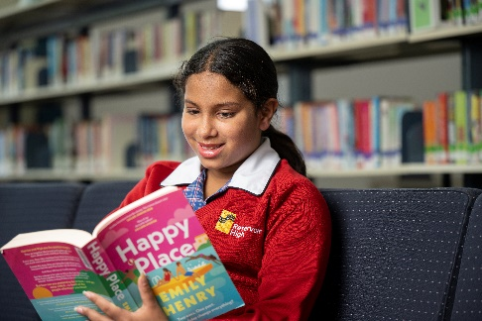
Academic Excellence Scholarships
$300
These are awarded to students who have demonstrated an excellent academic record throughout their primary school studies.

Leadership and Citizenship Scholarships
$300
These are awarded to students who have demonstrated leadership skills and been positive role models for their fellow students.

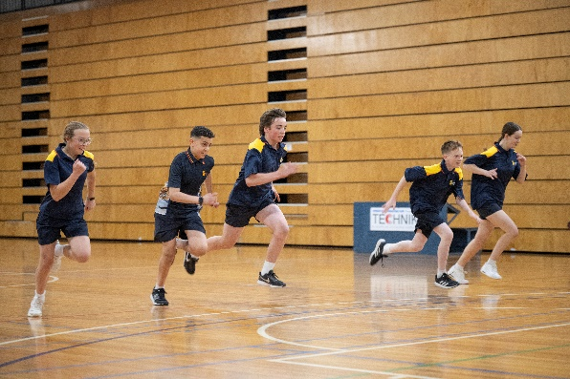
Sport Scholarships
$300
These are awarded to students who can demonstrate excellence across at least two sports (one in exceptional circumstances) and have evidence of potential leadership in sport.

Performing Arts Scholarships
$300
These are awarded to students who can demonstrate excellence in Performing Arts e.g. dance, vocals, instruments.

Parents/Guardians are invited to complete the Expression of Interest form overleaf and return to Reservoir High School by Wednesday 10th June, 2026 to reservoir.hs@education.vic.gov.au

